Welcome to the College Center!
We are located in Room 180
Drop Ins Welcome before school, at break, lunch or after school.
Appointments required during periods 1 - 4

STUDENTS, you may schedule a college planning appointment by clicking on the name below of the person you would like to meet with. If you there is not availability soon with the person you pick, try one of the others:
Grades 9 - 12
Mrs. Singer, College Center (Room 180)
Ms. Page, College Center (Room 180)
Ms. Villarreul, College Center (Room 180)

12th Grade ONLY
Mr. Gonzalez, NEW Admin Building
Mrs. Street, NEW Admin Building

You may reach the College Counselor via email, Mrs. Cathy Singer, or by coming to the college center during drop in hours. The college center is also staffed with graduate students from local universities learning to become school counselors. This Fall helix is honored to have on staff, Ms. Page and Ms. Villarruel. Everyone in the College Center is ready to assist you with any of your college needs.

Upcoming College Visits:
Sign up in Naviance (Colleges Tab)
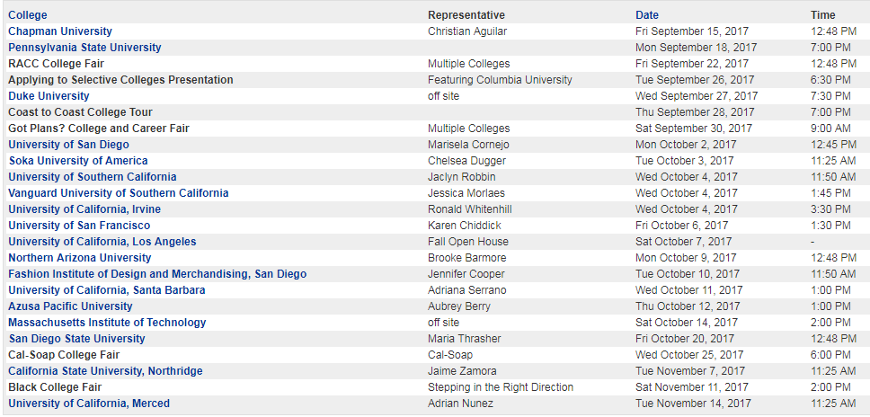

Important Announcements:

Club College
Tuesdays: During Tutorial Rm 180
Wednesdays: During Tutorial Rm 180
Wednesdays: 3:30 - 6:30 Rm 240

2018:
Time to get prepared for the SAT/ACT
- Are you going to take the SAT or SAT or both?
- Have you made an account on the testing website(s)? SAT ACT
  - Tips for setting up your account:
    - Use your LEGAL Name as it appears on your high school records
      - if you have more than one last name, put them all.
      - not matching your high school records can cause problems in college admissions
    - Use your personal email account
      - You will not have access to your helix email after you graduate and you may find a need to access your account later in life
      - Use the SAME email for all accounts for college
    - Use your Helix Password
      - It is VERY easy to get yourself locked out of your accounts and it can be very frustrating when completing applications for college admissions when you get locked out of your testing account.
    - Create a college account Google Doc
      - record the
        - website
        - username
        - password
        - email account used
      - Share this document between your Helix account and your personal account
      - record ALL college related accounts on this document
- What Month are you going to take the test?
  - Registration deadlines are usually one month prior to the test, so plan early
  - for actual test dates/registration deadlines/fees go directly to the testing website:
    - SAT
    - ACT
- Set up a practice schedule...
  - Time you will spend each week from now until the test going on line and preparing for the test.
  - FREE Online Test Prep for ALL Helix Students. SAT, through Kahn Academy and ACT, through Naviance.
It is Collge Application TIME!
- Complete your list in Naviance of COLLEGES I'M APPLYING TO
- Are you applying to a UC school?
  - Application is OPEN NOW!
  - Complete your UC application First
  - After application is complete then finalize personal insight responses
  - GOAL: Have everything COMPLETED by September 30th, Submit on November 1st
- Are you applying to a private/out of state school?
  - Application is open NOW
  - If Common application is an option, you should consider as this ONE application can be sent to over 700 different schools
    - Steps to matching your common application for recommendations to be sent.

